14.01.2023

200444008 Nazlıcan AYDIN

200444031 Selen Nur AKBULUT

200444409 Tolga ÜNLÜ

200444058 Eda ŞENTÜRK

Term Project Report

To Execute The Project;

1-We brought the data from the MSSQL Database in the project. MSSQL is installed and the MSSQL link that we have provided in the zip file must be added to the location where the MSSQL database is installed.

2- After the database is loaded, the Server part on the conn line in the project must be changed. (db.connect('Driver={SQL Server};'

'Server=TUNLU-PC;'

'Database=TermProjectOOP;'

'Trusted_Connection=yes;')

3-The libraries used in the project must be written to CMD with the commands we have given below and uploaded to the computer.

-pip install pyodbc

-pip install ssl

-pip install smtplib

-pip install opencv

-pip install numpy

-pip install Pillow

-pip install EmailMessage

-pip install tkcalendar

Project Guide

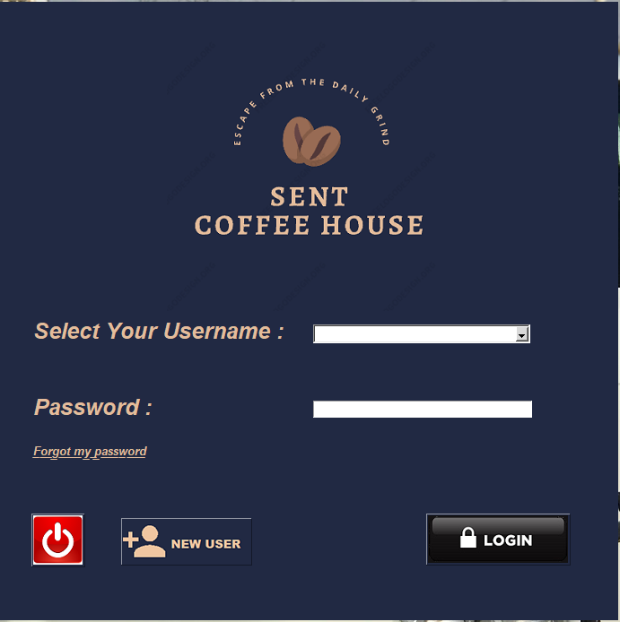The project starts with the frmLogin function. The name of the users registered in the database in this function is "ttk.combobox” is displayed in the "combobox" feature that we got from the "combobox" library, and thanks to the "tkinter entry", the user is expected to enter the password of the user it selected from the combobox correctly. If the user has entered the username and password s/he has selected correctly, it is allowed to switch to the frmShowProduct tkinter frame. If incorrect information is entered, the program alerts the user by sending a message.

The data that are come from the database:

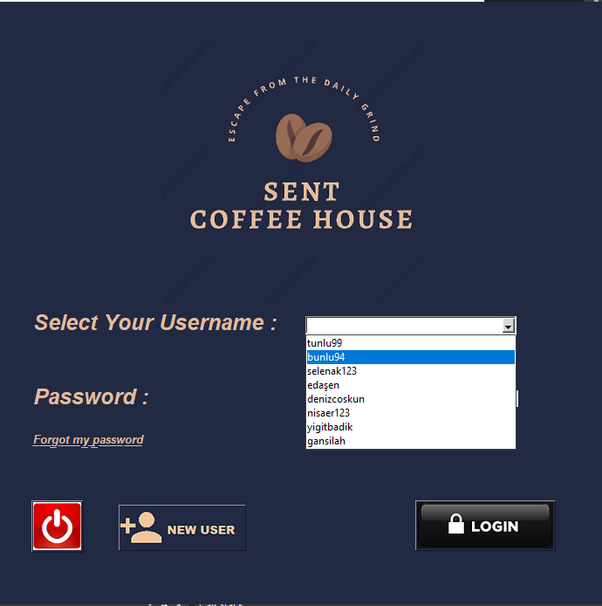

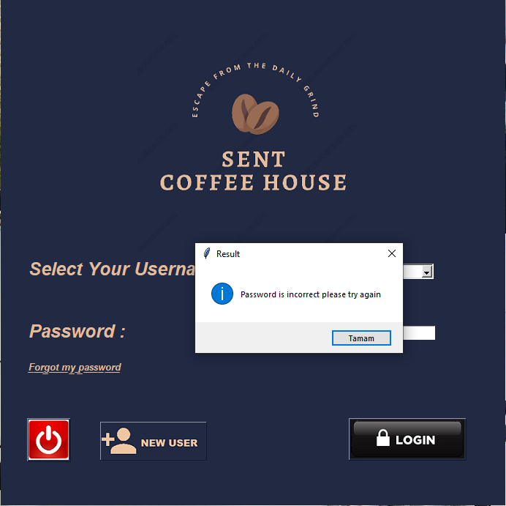 If the data are entered incorrectly:

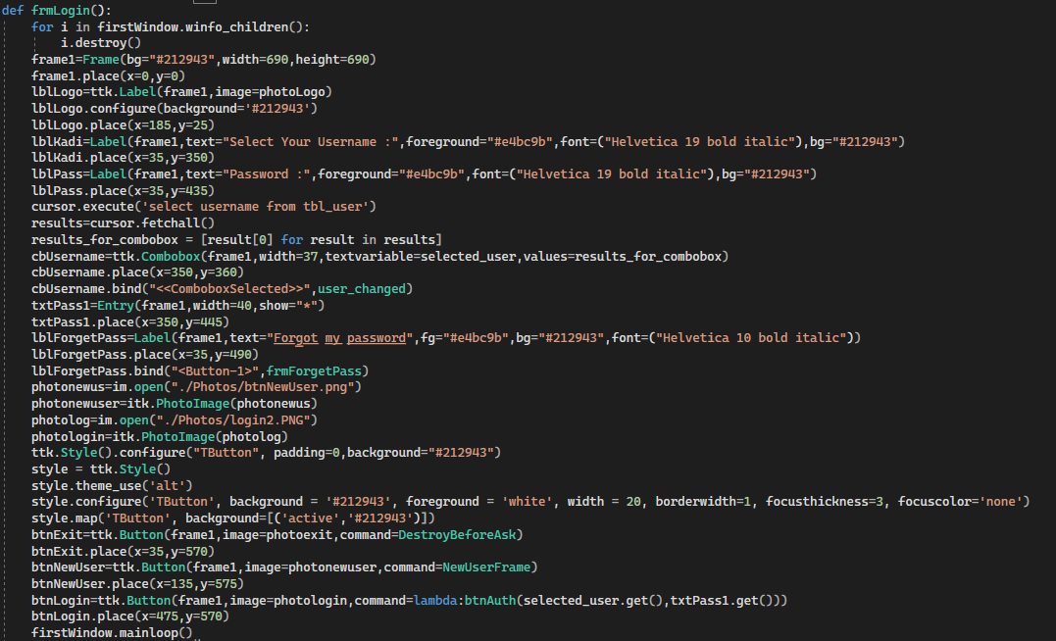 frmLogin() codes:

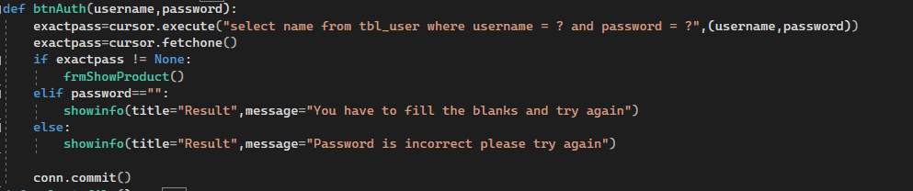 Codes of the “btnAuth” function, which fetches the data from the database:

Added a New User button to the “frmLogin()” page so that the user can add another new user. In this way, the user can add another new user to the database:

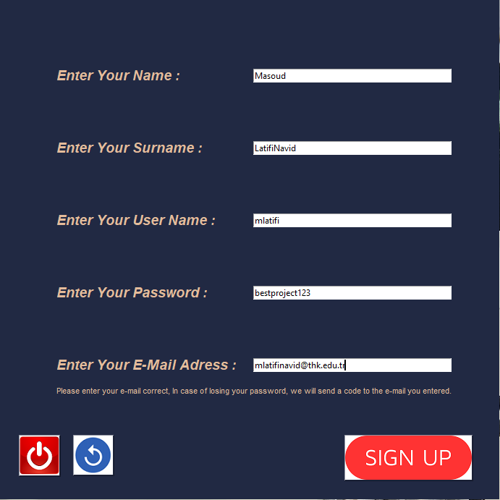

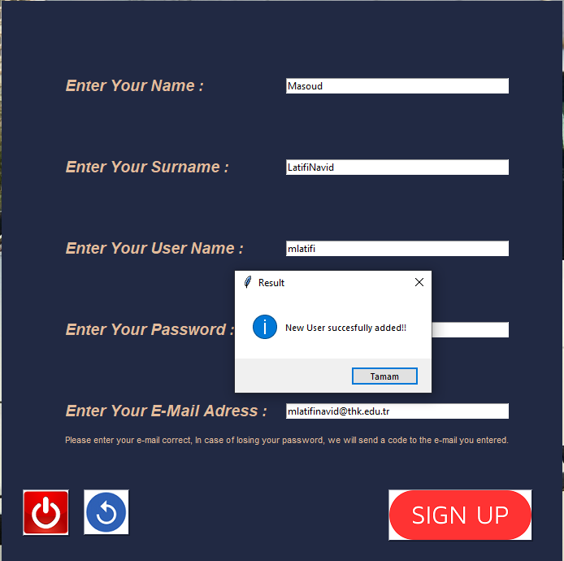 When the user has been successfully added:

If the gaps are not filled, the transfer to the database is blocked and gives an error.

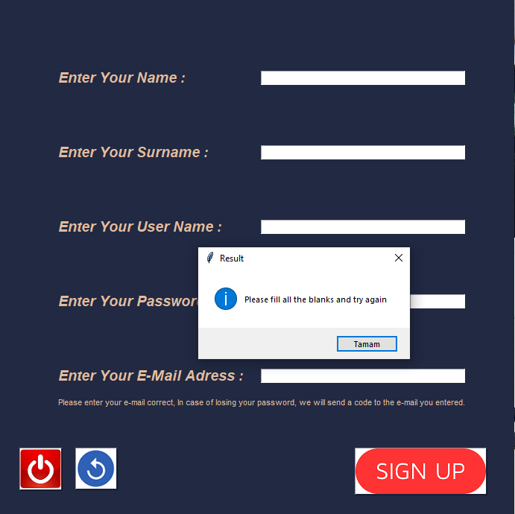

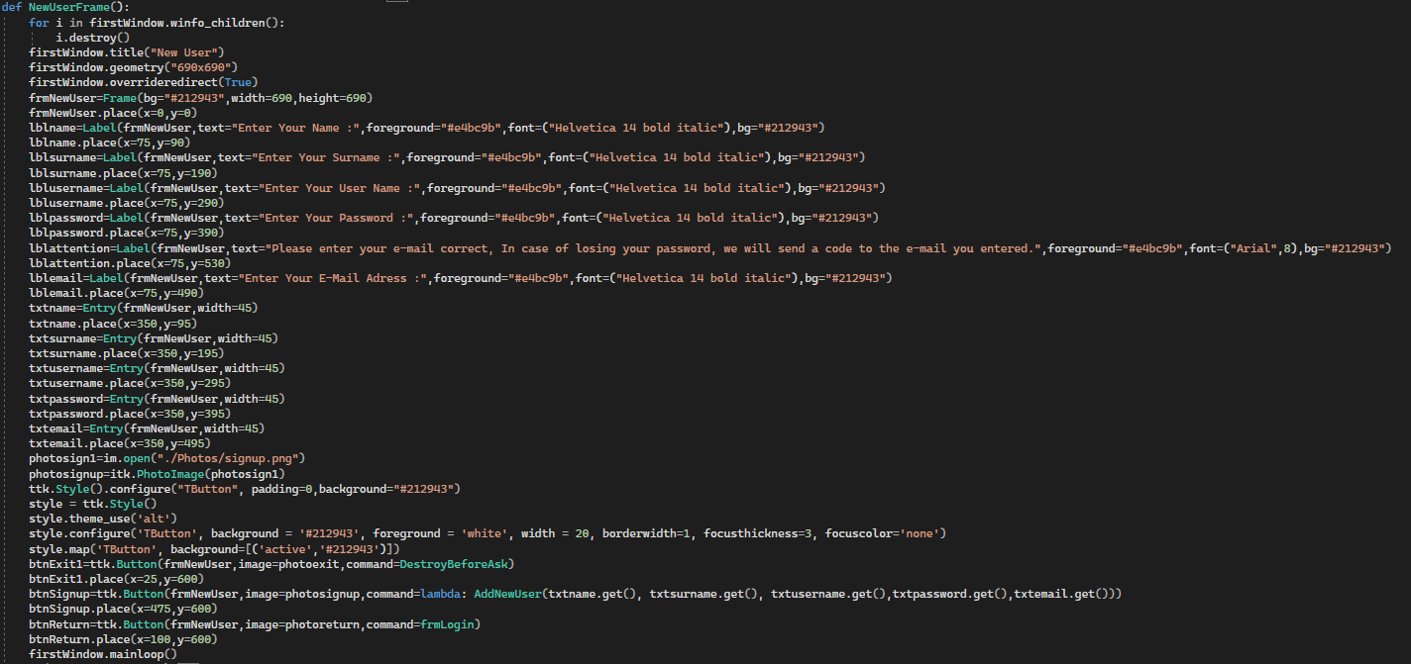metin içeren bir resim

Açıklama otomatik olarak oluşturuldufrmNewUser() codes:

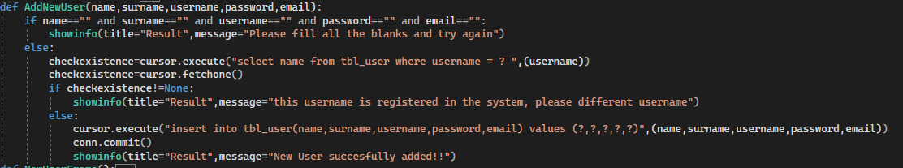Adding codes to the database:

In case the registered user forgets his password, the password is sent as an email to the e-mail address entered when adding the user. In this way, the user can log in to the system.

The Code that Sends the Password to the Mail (We used the SMTP and EmailMessage libraries.):

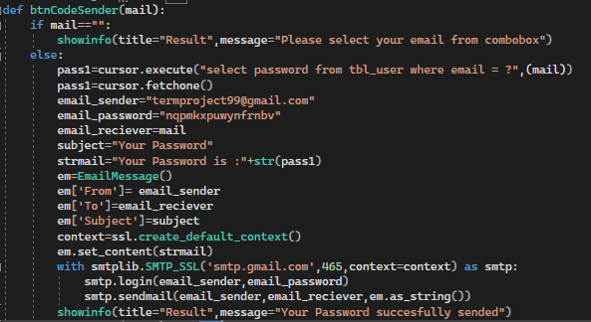

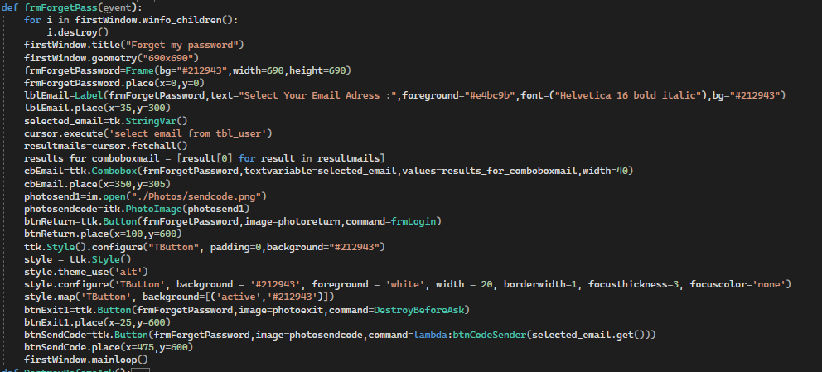frmForgetPass() codes:

frmForgetPass() image:

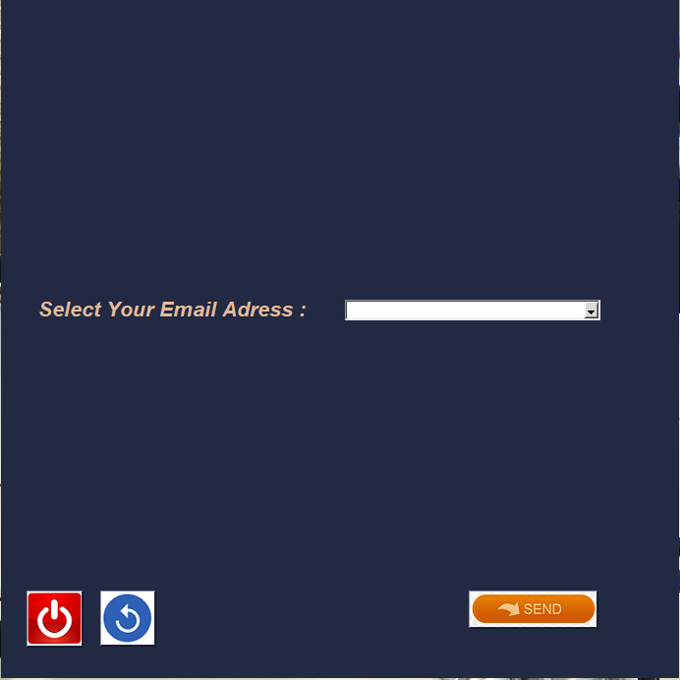

Data that are come from the from the database to frmForgetPass() Combobox:

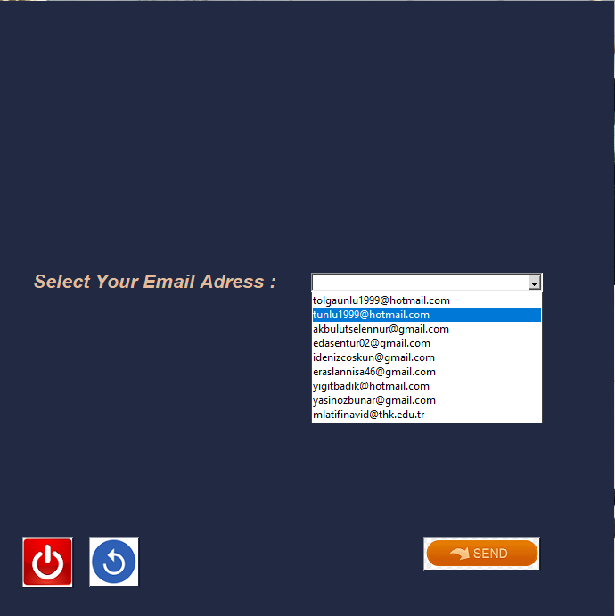

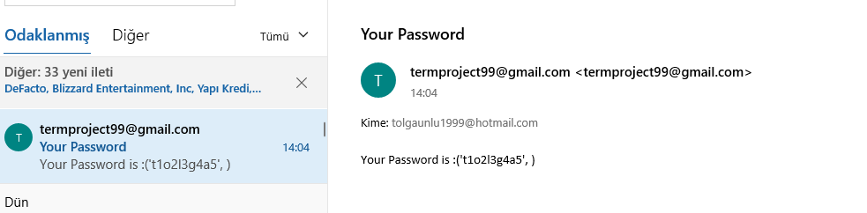 The appearance of the sended mail:

frmForgetPass() sent the e-mail successfully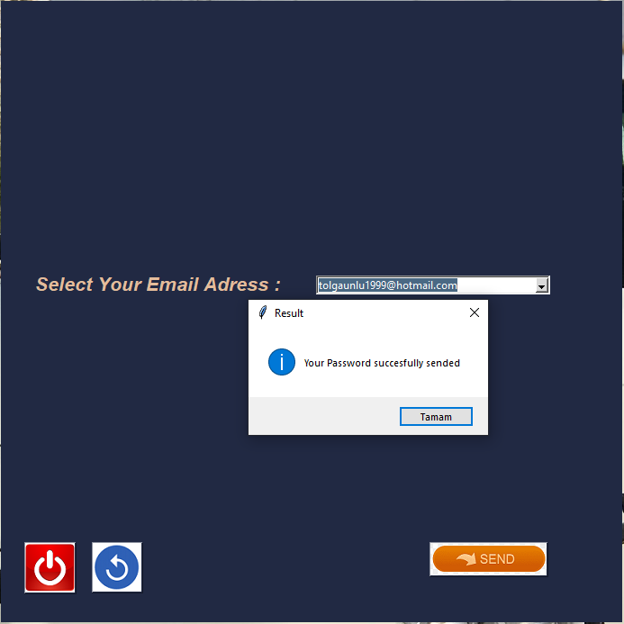:

If the user selects the username correctly and enters the password correctly, the frmShowProduct() frame starts working. Within this frame, the photo of the coffee product to be selected and the product information are displayed in the entrances. At the same time, the Camera button located here also creates a frame that opens the instant camera.

frmShowProduct() image:

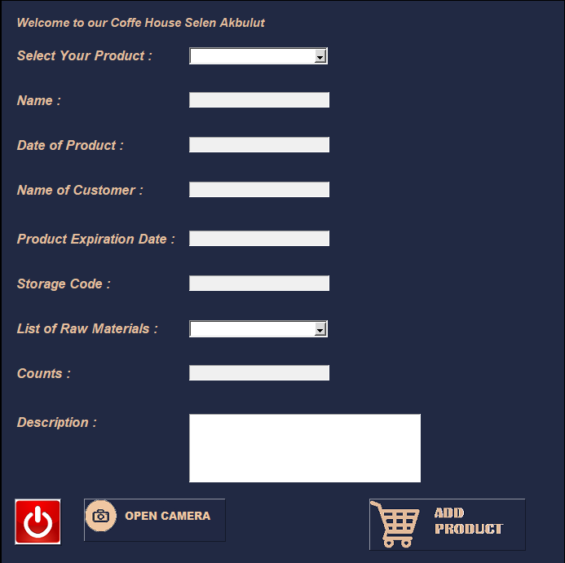

The appearance of the product when data is pulled from “frmShowProduct” combobox:

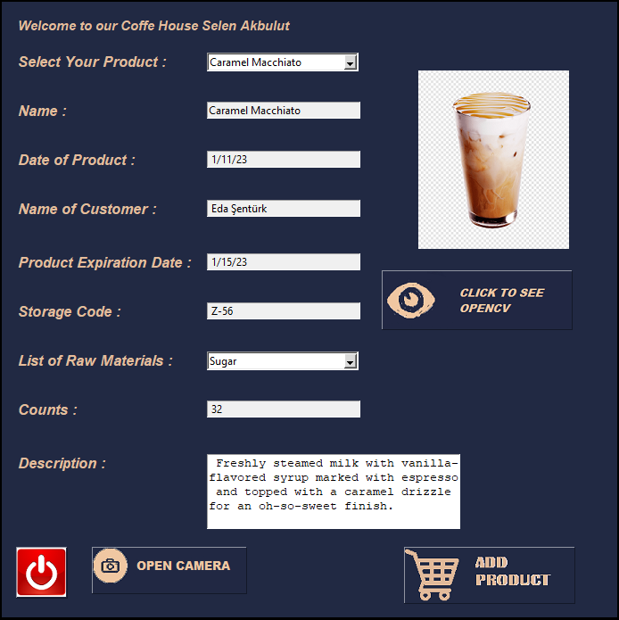

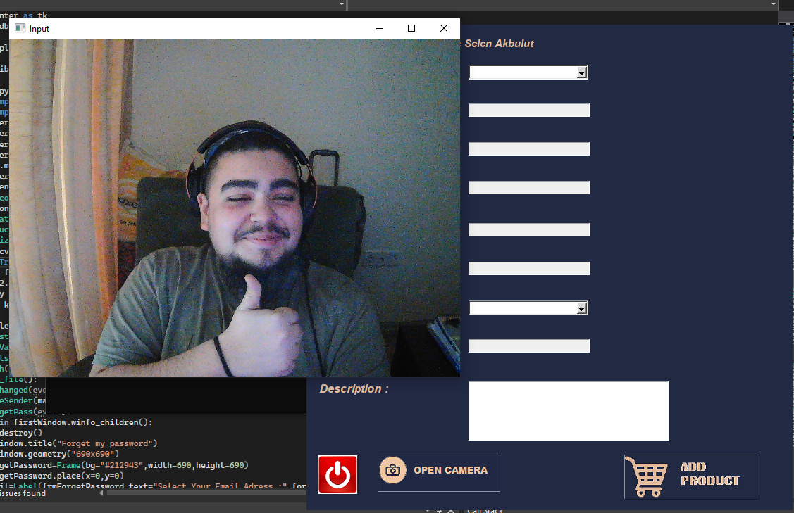 The image that appears when the "Open Camera" button is clicked:

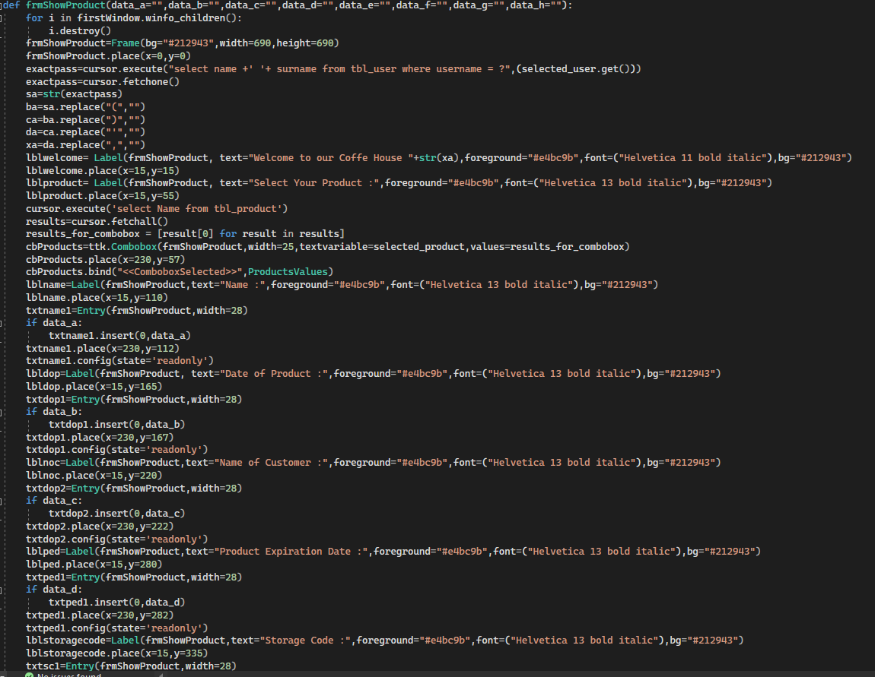 “frmShowProduct()” code 1:

“frmShowProduct()” code 2:

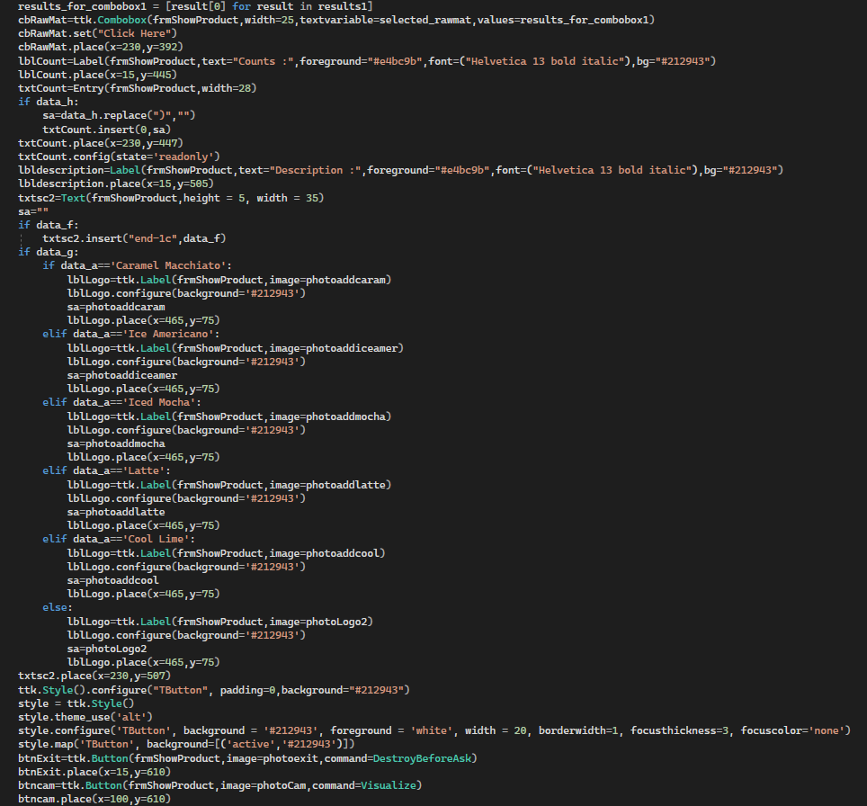

The code which is open to camera:

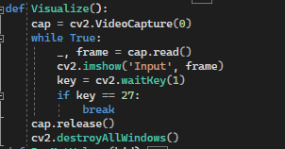

The code of product’s information that come from database:

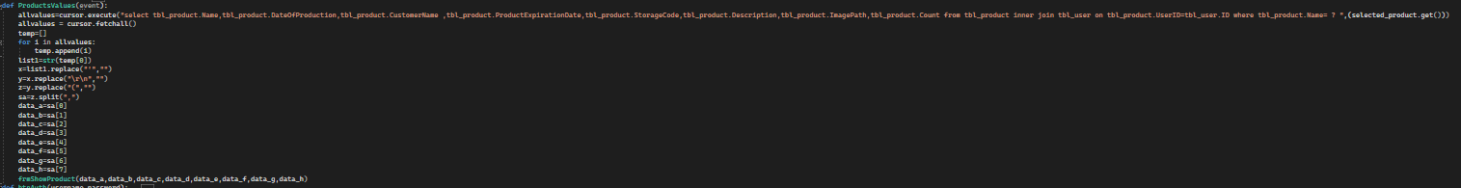

If the user wants to add a new product, user can switch to the “frmAddProduct” frame by clicking on the New Product button located in “frmShowProduct”. The new product to be added from this frame user can register by entering the properties, entries and pressing the new product button. Here, in order to be easy to use for users, we used the “DateEntry” method from the “DateEntry” library for entering date entries. In this way, users can select dates from the calendar instead of entering them manually. At the same time, rawmaterials in the new product to be added can be added rawmaterial by pressing the button once, double-clicking rawmaterial can have information about.

Again, in order to be a user-friendly program, instead of manually typing the path of the product image to be added, we added the filedialog library that allows you to open and read files where only pngs can be selected, so the user can select the desired png file by clicking the "select an image" button, and as soon as the png file is selected, the path of this file will be written to the input, and the selected file image can be displayed in the right corner, and after each entry is entered correctly, the "add product" button can be added to the database.

The first image of “frmAddProduct”;

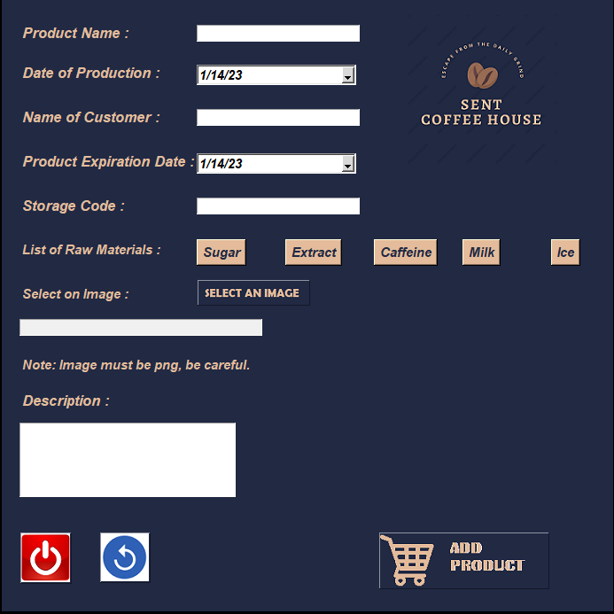

Appearence “frmAddProduct()” DateEntry:

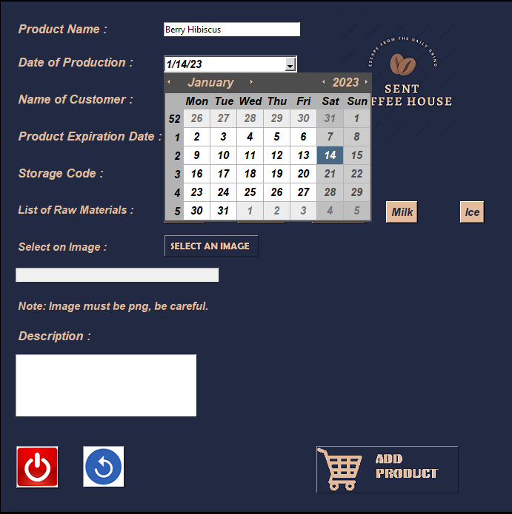

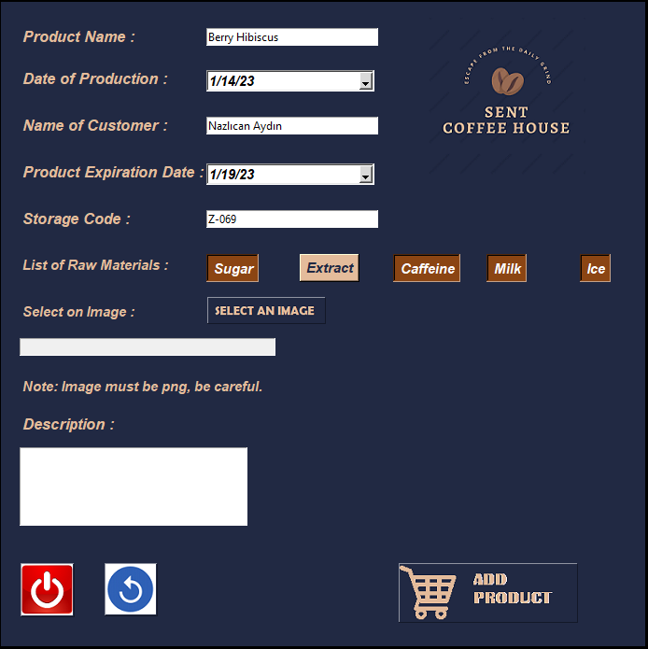“frmAddProduct()”, the mode of adding Raw Material buttons:

“frmAddProduct()” the frame for obtaining information about raw materials:

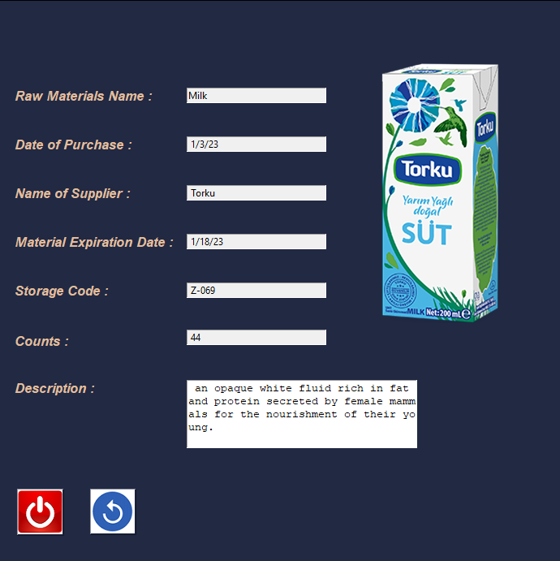

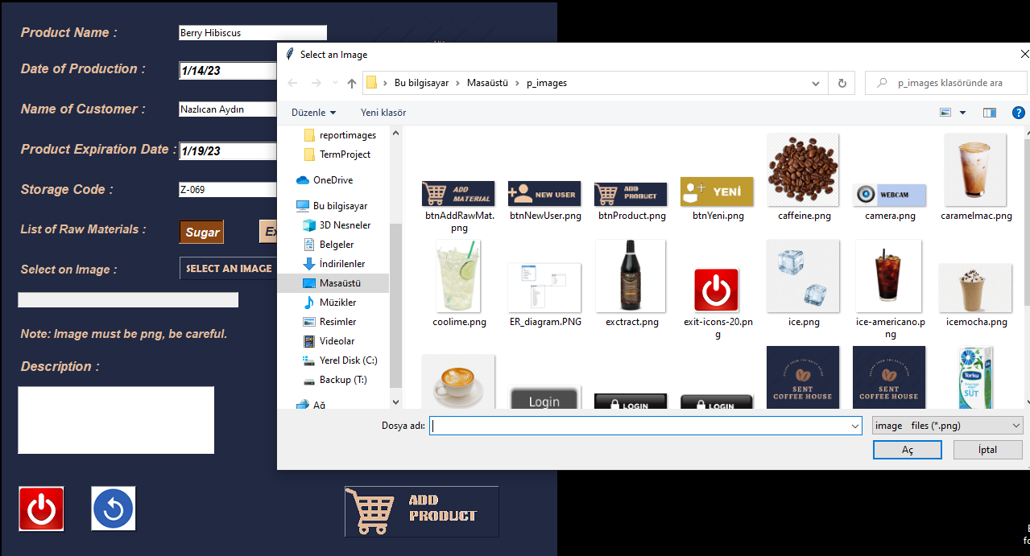“frmAddProduct()” file selection image:

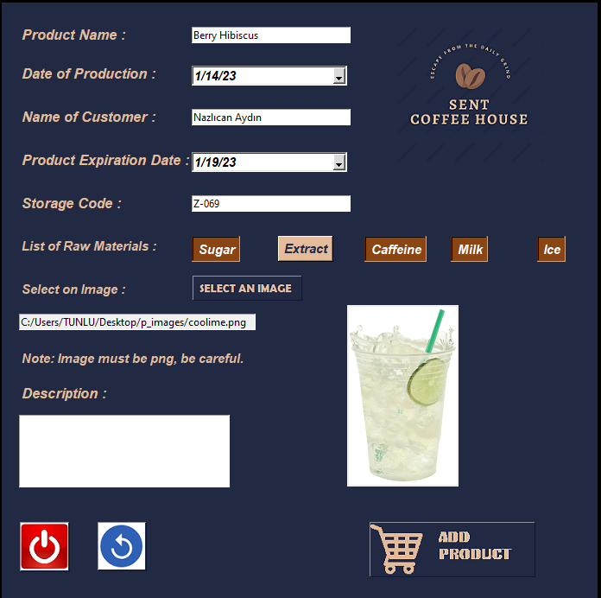“frmAddProduct” when the png file is selected, the image:

“frmAddProduct” the success message that appears when the data is entered correctly:

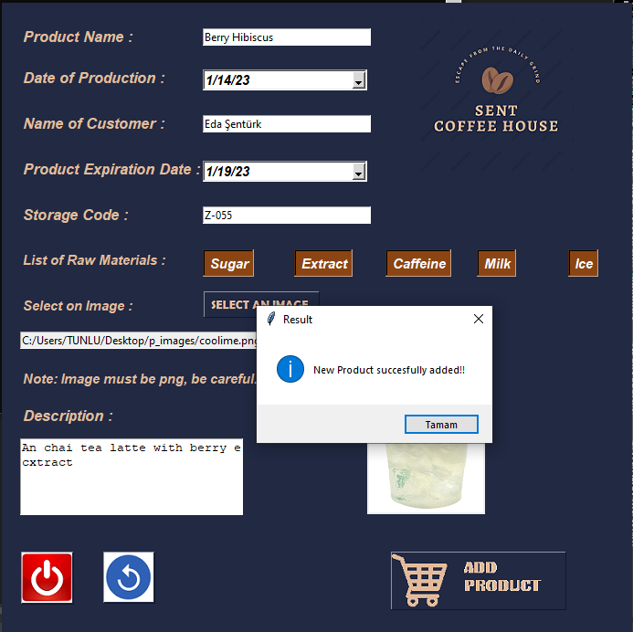

“frmAddProduct” code:

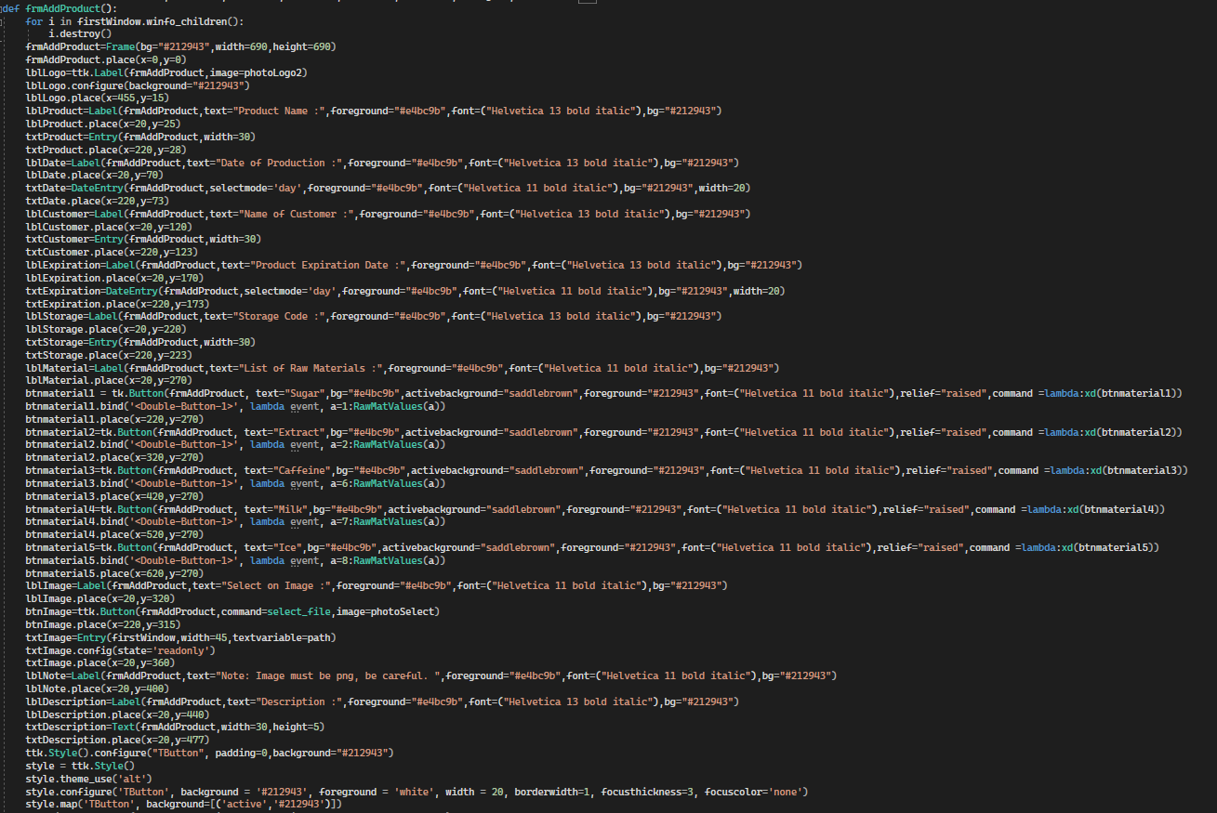



The required code to add the data to the database:

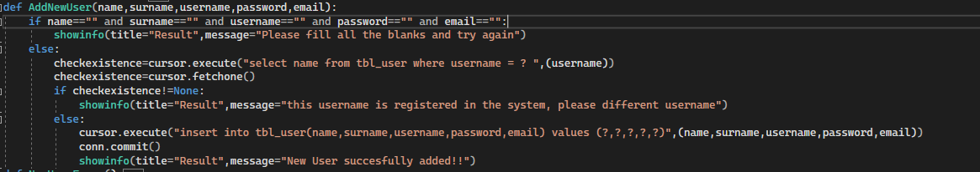

The code for Toggle button:

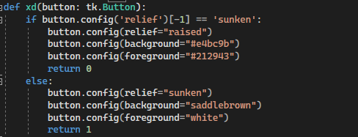

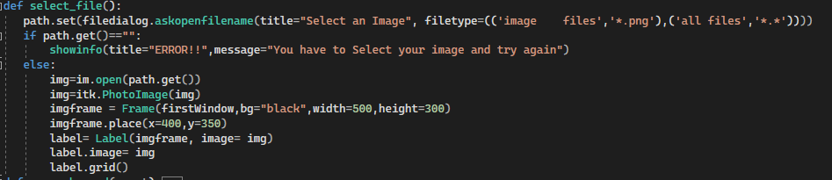 Code for selecting file:

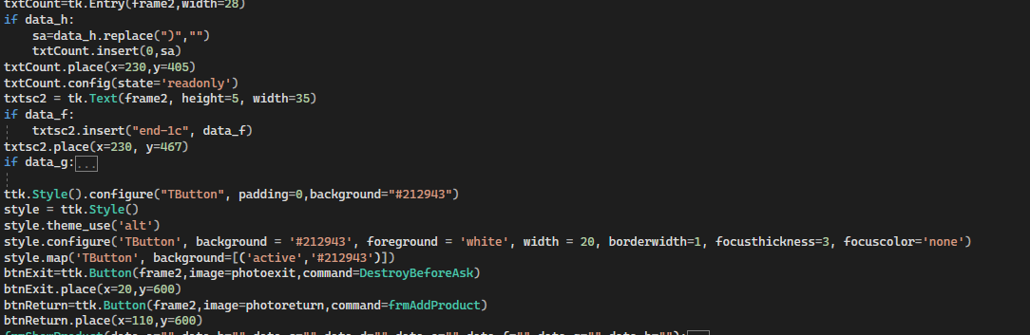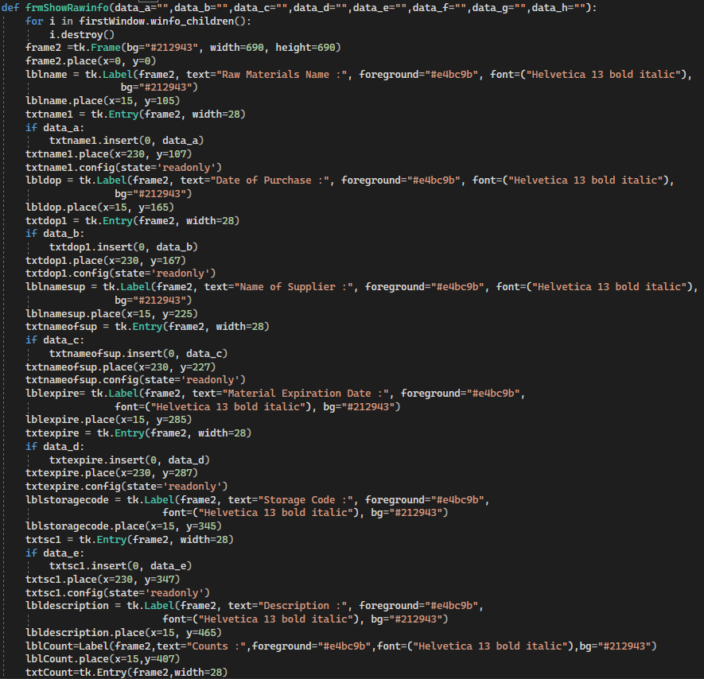 The frame in which the properties of Raw Materials are shown:

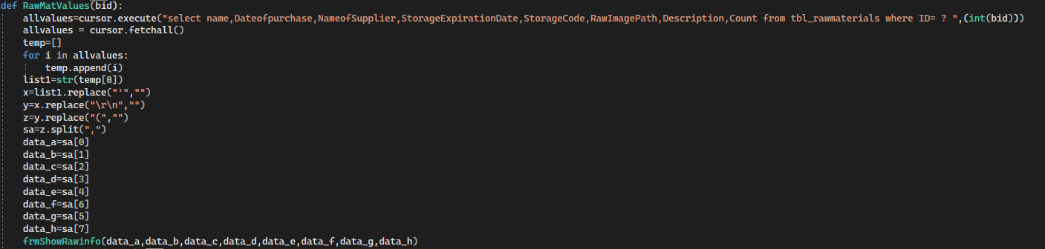 The code required for Raw Materials to come from the database:

Database ER Diagram of the project:

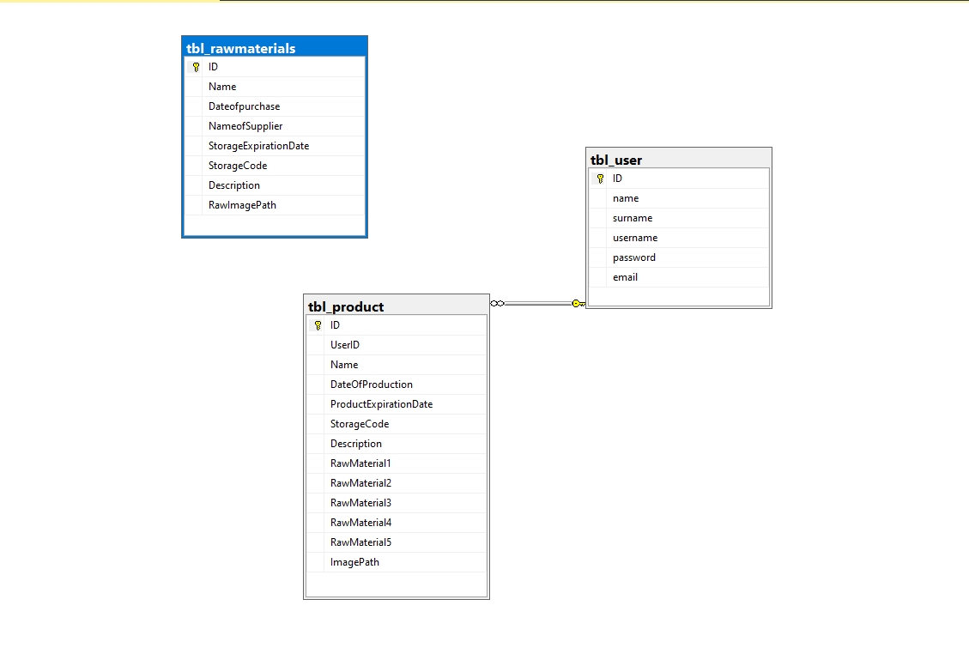

Flow diagram of the project:

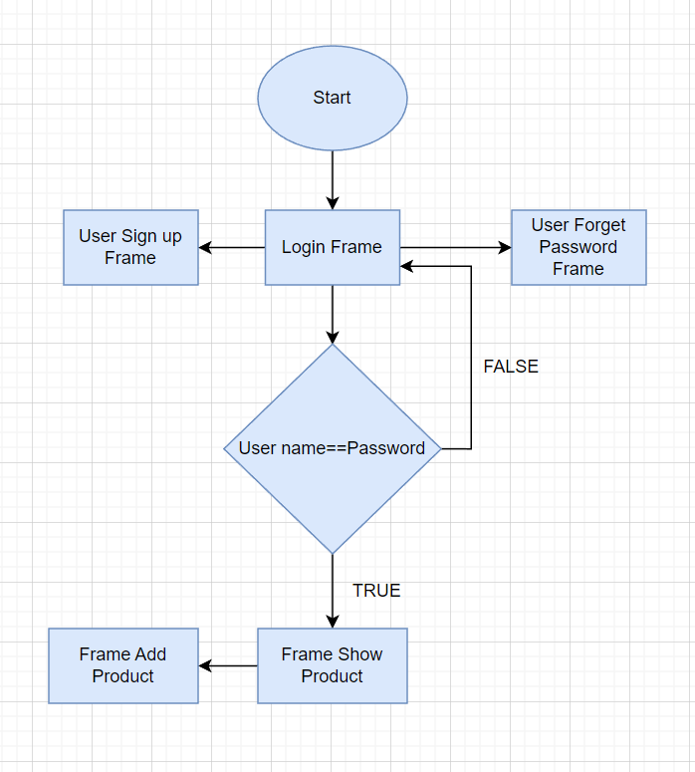

Distribution of Tasks

Although we made a task distribution when starting our project, we did not follow this plan. All members have actively participated in every stage of the project. For example, during the creation of the buttons, one of us added the toggle feature to it, while the other of us made it give an output to the terminal when the button was clicked. We were always together when the project was being made, so no one did not write code alone. Four of us have labor in each line.

We wish that there has been a project that meets all the requirements and that you will like. We express our thanks.